B.Sc. Hons Semester-V Practical Examination: 2020-2021
Ramananda College, Bishnupur, Bankura
Course Code: 52621(C11). Sub: Molecular Biology (Zoology)

Time: 2 Hours Full Marks:15

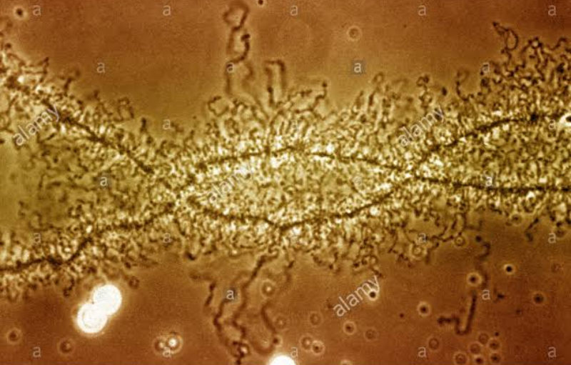
1 Identify the given electron micrographs with reasons:- 5 (2.5 X 2)
i)
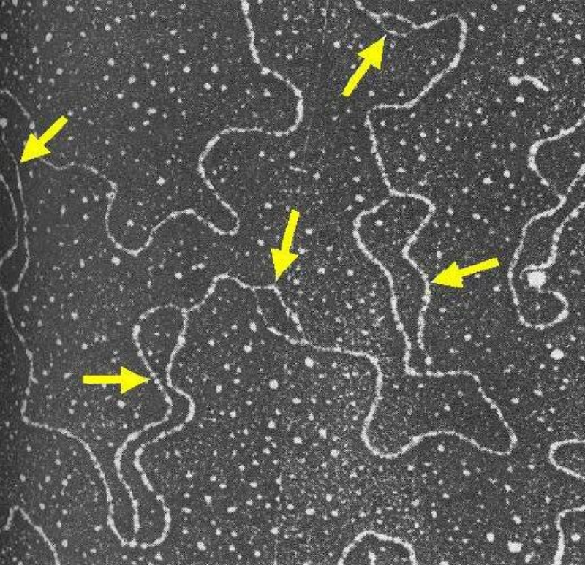
ii)

Identification 1 mark
Reasons 1.5 marks

2. Draw and label the polytene chromosome. 8
Mention the procedure for the preparation of polythene chromosome from Drosophila larvae.
Drawing 1 mark
Labelling 1mark
Procedure 6 marks

3. Laboratory note book/ Viva voce 2
***************

